**AIM:**  Design DFA using simulator to accept strings in which a’s always appear tripled over input {a,b}

**INPUT:**

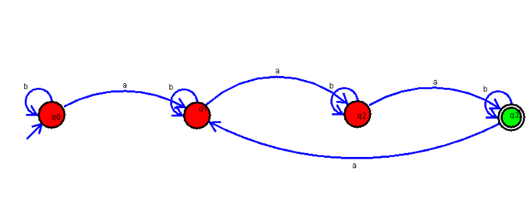

**OUTPUT:**

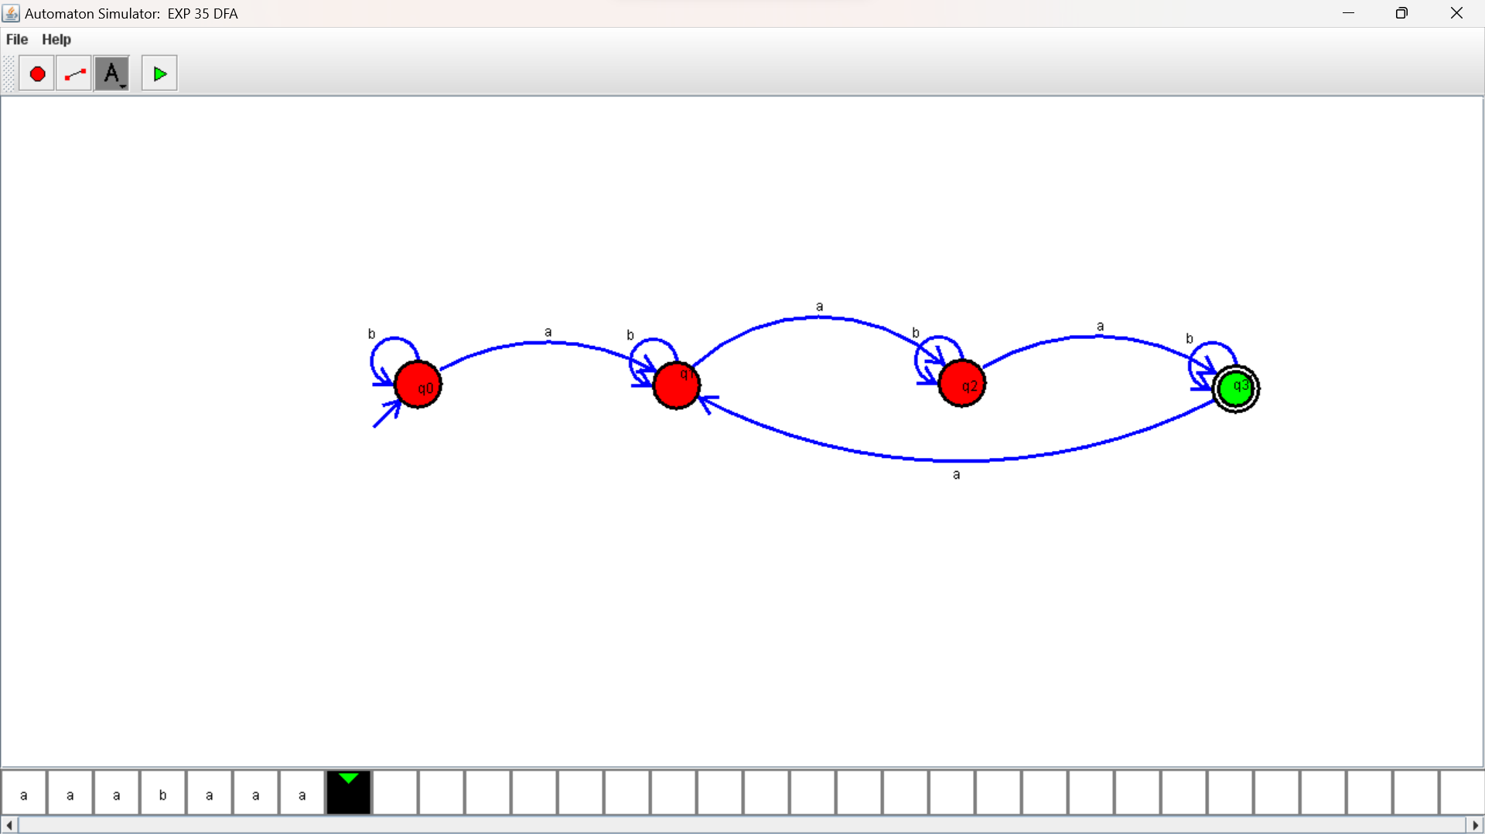

**RESULTS:**

DFA using simulator to accept strings in which a’s always appear tripled over input {a,b}